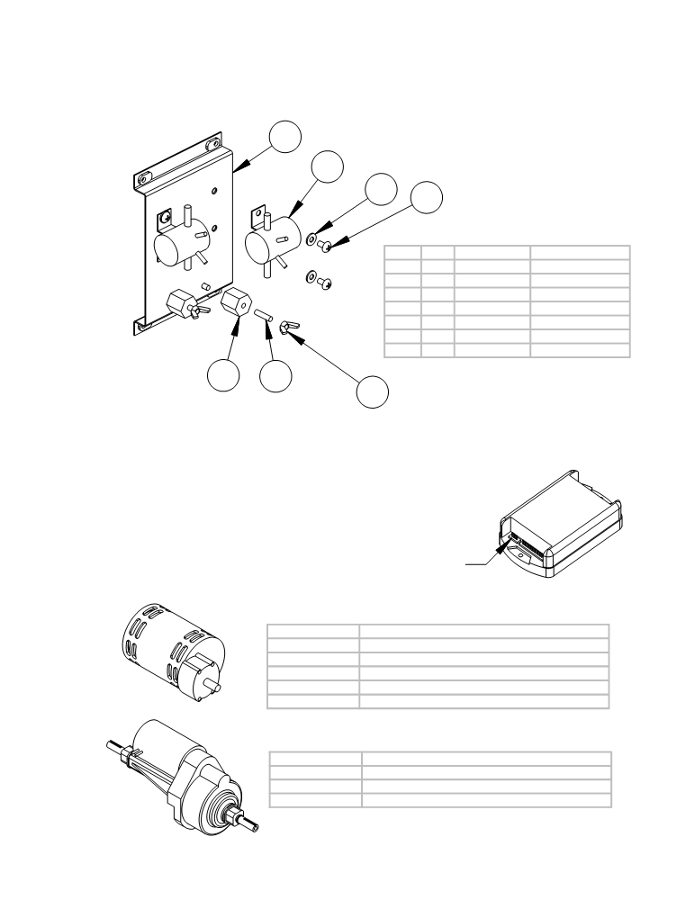

ELECTRICAL PANEL AND PARTS
AND OTHER ELECTRICAL PARTS

1
2

7

ITEM | SKU | Description | QTY
1 | E11890 | ELECTRICAL PANEL | 1
2 | E11230 | SOLENOID (36V) | 2
3 | E11730 | INSULATOR PLASTIC | 2
4 | AS26/32302 | Brass stud | 2
5 | E11177 | 1/4 NUT WING | 2
6 | E11189 | 1/4-20 x .5 screw | 4
7 | E81713 | Washer 1/4 in flat | 4

ITEM
1
2
3
4
5
6
7
6

QTY. PART NO. DESCRIPTION
1 AS26/321108 Electrical Panel
2 AS26700 Solenoid
2 AS26/32800 Terminal Block
2 AS26/32302 Brass stud
2 AS26/32246 Wingnut
4 AS26/32258 Screw
4 AS26/32279 Washer

3 4
5

THERE IS A PROGRAMMER AVAILABLE FOR THE SPEED CONTROL. IT ALLOWS THE USER TO ADJUST OPTIONS, SUCH AS:
MAXIMUM SPEED IN FORWARD AND REVERSE,
ACCELERATION, AND MORE. IT ALSO HAS
FAULT FINDING CODES TO HELP TRACE
PROBLEMS. IF YOU ARE INTERESTED,

PLEASE CALL AND ASK ABOUT
THE SP1A PROGRAMMER.

PART NO. | BRUSH MOTOR PARTS
E10507 | Brush motor 36v
E11932 | Commutator Bracket ASM
 | (includes commutator bracket,
 | brush board asm, brushes and springs)
AS26/321846 | Gear Box Not Available

PART NO.
AS26050
AS26/321845

AS26/321846
PROGRAMMER
PLUGS IN HERE

BRUSH MOTOR PARTS
Brush Motor - 24 volts
Commutator Bracket Assembly
(includes commutator bracket,
brush board assy, brushes and springs)
Gear Box

E10509 | Transaxle 36V
AS261847 | Not Available
AS26/321848 | Not Available

PART NO. TRANSAXLE PARTS

AS26051 Transaxle - 24 volts

AS261847 Motor for Transaxle - 24 volts

AS26/321848 Motor coupling for transaxle

